**ML XQDT**

**About XQDT:**

XQDT is a set of open source plugins for the Eclipse IDE, providing support for syntax highlighting and content-assisted editing of XQuery modules, and a framework for executing and debugging modules in a supported XQuery interpreter.

It helps developers to write & execute XQuery scripts supported with MarkLogic APIs on MarkLogic server with the help of XDBC app severs. It uses XCC.jar to establish the connection with MarkLogic.

A connection using XCC.jar to MarkLogic XDBC server is so called XQuery interpreter.

XQuery scripts will be executed over the Database configured in the XDBC server.

**Note:** Modules can be executed on the server, with results displayed in the IDE. Debugging is not yet supported.

**System Requirements:**

* **Java:**

Java runtime environment is required to run the Eclipse IDE.

* **Eclipse IDE:**

Version 3.6 (Helios) recommended or higher.

* **MarkLogic Server:**

Server must be running and an XDBC application server must be configured.

Assuming you have the server installed and running, enabling XQDT simply requires creating an XDBC server.

In the Admin Interface, navigate to **Groups > Default > App Servers**.

Select the **Create XDBC** tab, fill in the required fields, and click **OK**

Remember the port number for the new server for use in setting up XQDT.

**Steps to configure the XQDT:**

**Step 1-** Launch Eclipse IDE.

**Step 2-** Install XQDT as a **dropin** in Eclipse IDE.

* Download the XQDT plugin from below given link.

[**http://developer.marklogic.com/download/code/eclipse/xqdt-dropin.zip**](http://developer.marklogic.com/download/code/eclipse/xqdt-dropin.zip)

* Unpack the **xqdt-dropin zip** file into the **dropins folder** under Eclipse. You should see the following hierarchy under the main Eclipse folder with the zip unpacked (***eclipse***) into the dropins folder.

A folder named “eclipse” will be unpaked after extraction of xqdt –dropin zip file.

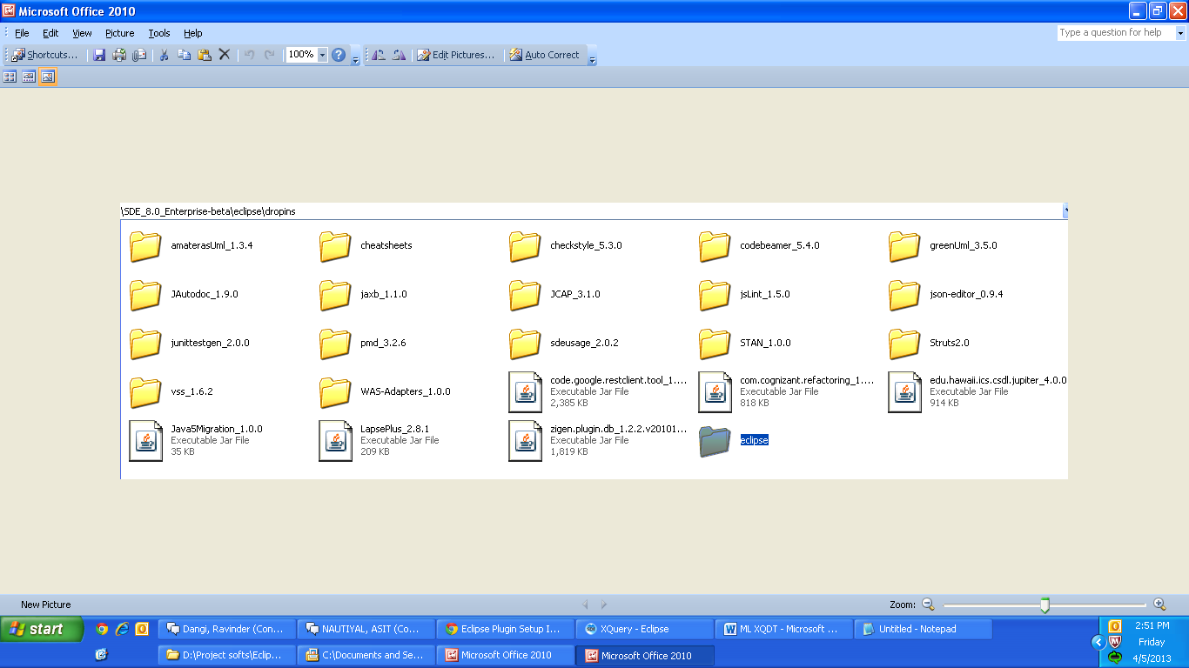

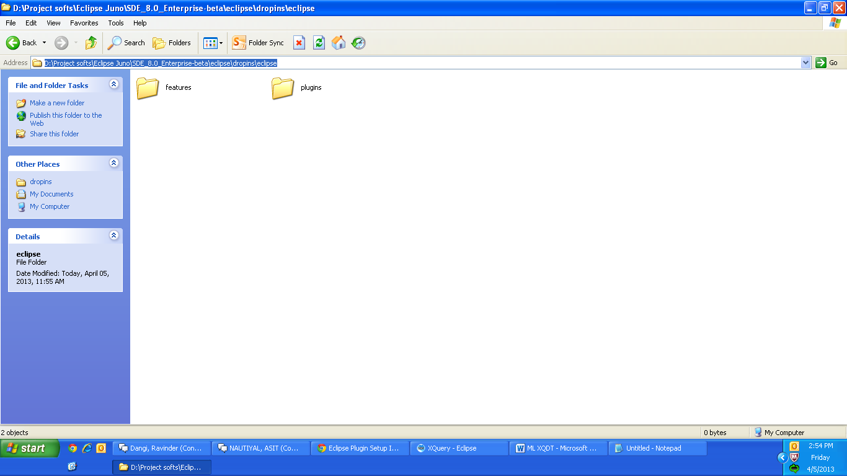

* Restart Eclipse when you are done.

**Create your first XQuery Project:**

Follow the steps given below-

**Step 1-** From the menu bar, select **File > New > Project**

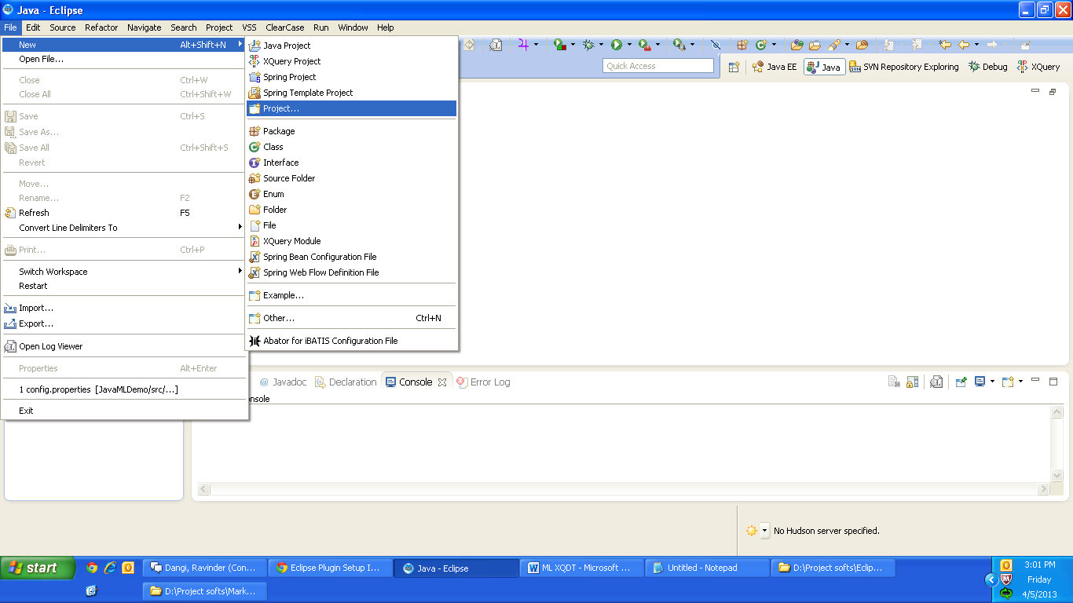

**Step 2-** Choose **XQuery > XQuery Project** and click [Next..]

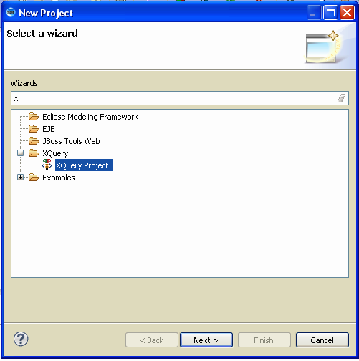

**Step 3-** Provide a project name (e.g. MLDemo) and configure an Interceptor. When you provide the project name first time after installing XQDT then it will indicate the “***An interceptor must be configured***”.

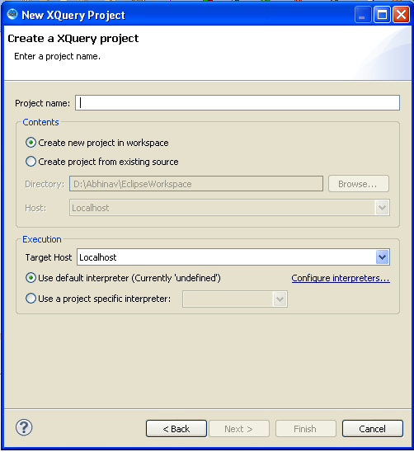

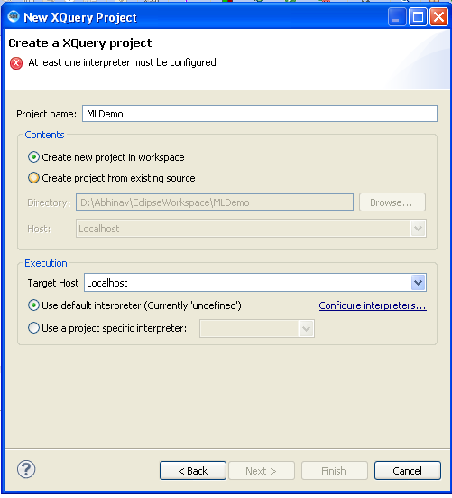

**Step 4-** Configure an interceptor, click on “**Configure interceptors**” link below Target Host drop down.

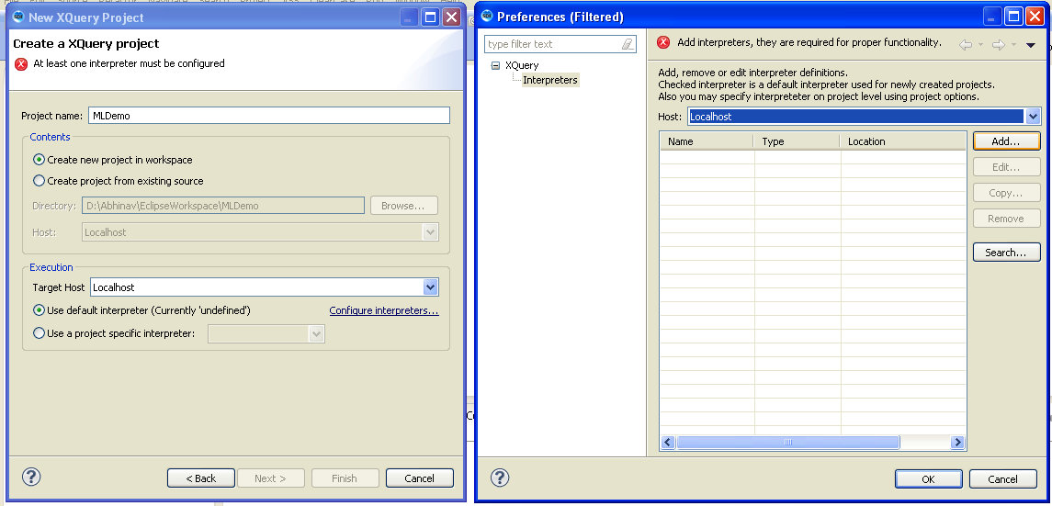

**Step 5-** Click on “**Add**” button, and select Interceptor Type as “**MarkLogic Server**”.

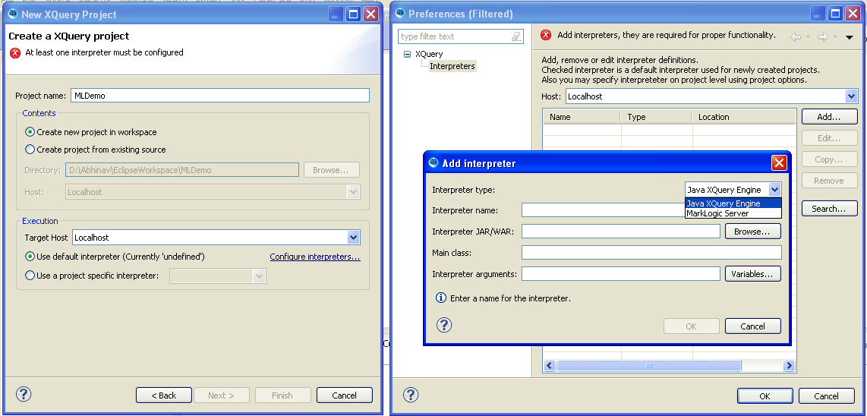

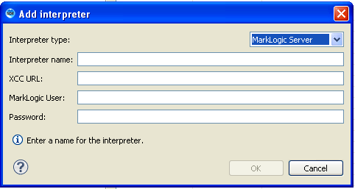

**Step 6-**

* Provide the Interceptor name (any name can be provided but should be meaningful).

For example: *MLConnectionInterceptor*

* Provide the XCC URL, URL of the XDBC server which you have configured.

For example: *xcc://localhost:8003*

* Provide the user name of MarkLogic.
* Provide the password of MarkLogic.
* Press “**OK**” in Add Interceptor box.
* Again Press “**OK**” in Preferences box.

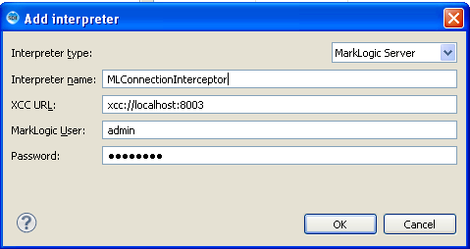

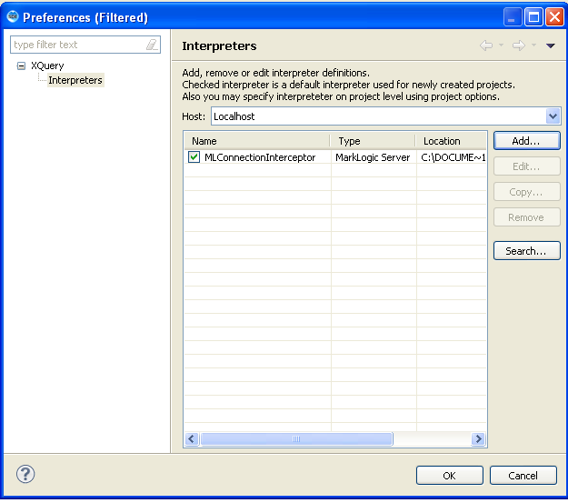

**Step 7-** In the “New XQuery Project” box, choose interceptor “***MLConnectionInterceptor***”.

* Click **Next > Finish**

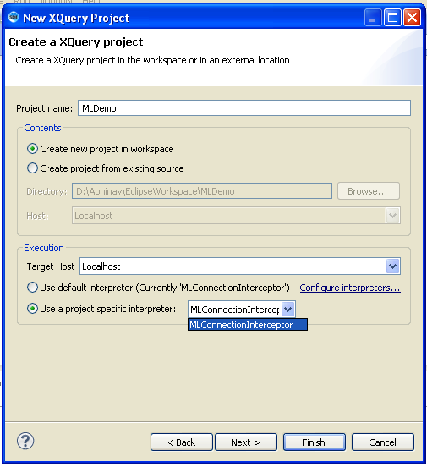

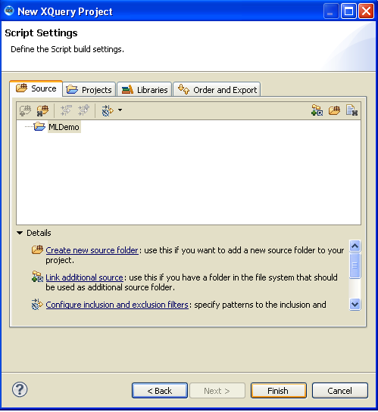

**Step 8-**

* Create an XQuery module, Go to File > New > Other > XQuery Module

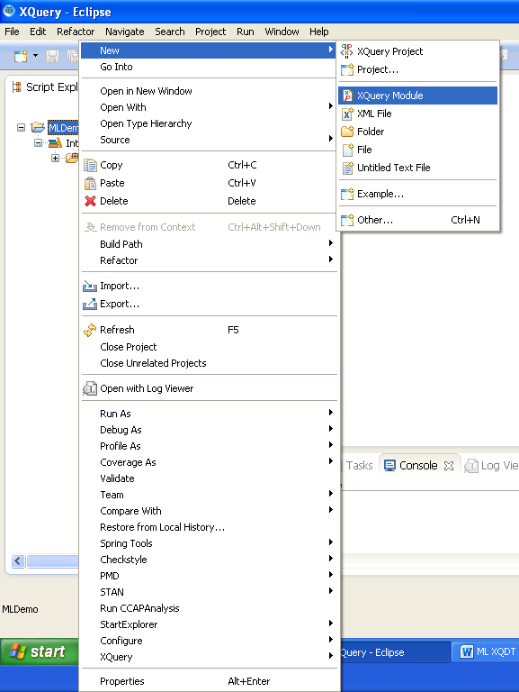

* Provide a module name, for example: “**testModule**”.
* Module setting will be “**Main Module**” by default. Choose “**Library Module**” if creating a library module.
* Click “**Finish**” button.

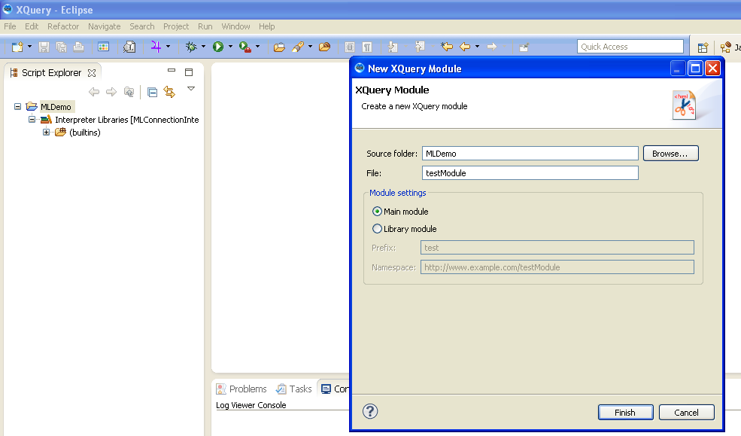

**Test an XQuery Module:**

* Write “Hello world” in the XQuery file to test the script.
* From a module editor window, ensure the module is saved, and run it by selecting **Run > Run** from the menu bar or right click on XQuery script in the editor and select **Run As > XQuery** to run the script.

Your results will be displayed in the Eclipse Console panel. Note that only main modules can be executed.

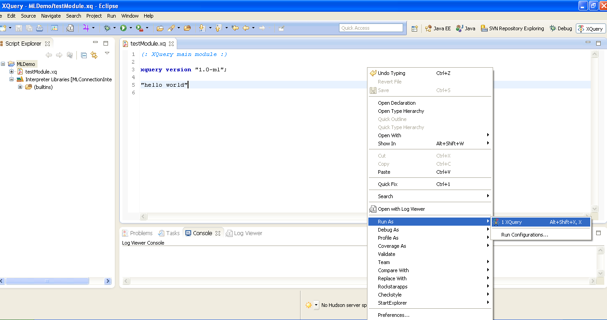

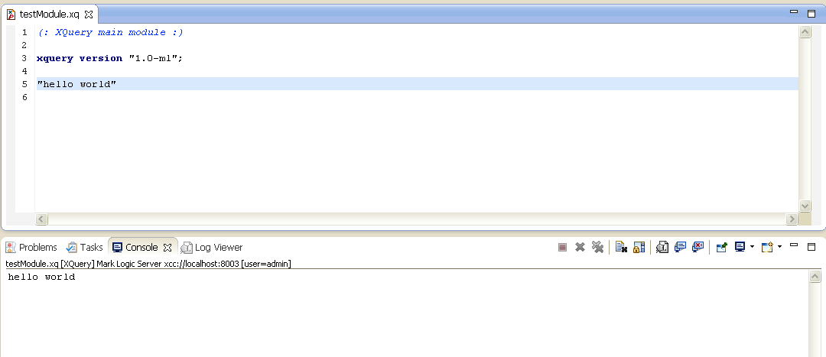

**Important Note:**

XQDT uses the version prolog to enable MarkLogic-specific features. It is always good practice to begin your modules with a version prolog, in order to guarantee correct behavior independent of the default settings of a particular MarkLogic Server instance. In general, your modules should start with the following:

**xquery version "1.0-ml";**